CelcomDigi Monthly Roaming Pass
1. Launch Details
Key Summary USP | Customers can use monthly roaming passes in 82 countries with up to 80GB data, including inflight roaming. There’s no contract and they can activate the pass directly via the app.
Channels | - CelcomDigi App  - UMB (USSD)  - CelcomDigi Store (CRM/CXI/MSA/PULSE)

2. Product Details
Offering Details | Passes Monthly 30GB Roam Pass Monthly 80GB Roam Pass  Segment Postpaid  Contract No  Monthly Fee RM40 RM70  Re-subscription Processing fee Waived until further notice  Validity (Follow bill cycle) 30 days 30 days  Auto-renewal Yes Yes  Roaming High Speed Internet Quota (Roaming internet will be blocked once the data quota is exceeded) 30GB 80GB  Hotspot Yes  Roaming Calls 15 Mins (Includes calls to Malaysia and calls received within present roaming country.)  Eligible Plans CelcomDigi Postpaid 60 and above (legacy plans not eligible)  50% Roaming Discount (CelcomDigi Postpaid 120 & above) Not applicable  Countries 3 Countries (SG, ID, TH) 95 Countries  Inflight Includes Inflight Connectivity (Aeromobile)  Roaming Add On RM10 for 5GB Valid for 24 hours
List of roaming countries:
Monthly 30GB Roam Pass |  | Monthly 80GB Roam Pass
No | Country List | No | Country List | No | Country List | No | Country List
1 | Singapore | 1 | Albania | 31 | India | 61 | Saudi Arabia
2 | Indonesia | 2 | Armenia | 32 | Indonesia | 62 | Serbia
3 | Thailand | 3 | Australia | 33 | Ireland | 63 | Singapore
 |  | 4 | Austria | 34 | Isle of man | 64 | Slovenia
 |  | 5 | Azerbaijan | 35 | Italy | 65 | South Africa
 |  | 6 | Bahrain | 36 | Japan | 66 | South Korea
 |  | 7 | Bangladesh | 37 | Jersey | 67 | Spain
 |  | 8 | Belarus | 38 | Kazakhstan | 68 | Sri Lanka
 |  | 9 | Belgium | 39 | Kuwait | 69 | Sweden
 |  | 10 | Brunei Darussalam | 40 | Kyrgyzstan | 70 | Switzerland
 |  | 11 | Brazil | 41 | Laos | 71 | Taiwan
 |  | 12 | Bosnia & Herzegovina | 42 | Latvia | 72 | Thailand
 |  | 13 | Cambodia | 43 | Lithuania | 73 | Tanzania
 |  | 14 | Canada | 44 | Liechtenstein | 74 | Timor-Leste
 |  | 15 | China | 45 | Luxembourg | 75 | Turkey
 |  | 16 | Congo DRC | 46 | Macau | 76 | United Arab Emirates
 |  | 17 | Croatia | 47 | Malta | 77 | United Kingdom
 |  | 18 | Cyprus | 48 | Mozambique | 78 | United States of America
 |  | 19 | Czech Republic | 49 | Nepal | 79 | Ukraine
 |  | 20 | Denmark | 50 | Netherlands | 80 | Uruguay
 |  | 21 | Egypt | 51 | New Zealand | 81 | Uzbekistan
 |  | 22 | Estonia | 52 | Norway | 82 | Vietnam
 |  | 23 | Finland | 53 | Oman | 83 | Argentina
 |  | 24 | France | 54 | Pakistan | 84 | Bulgaria
 |  | 25 | Germany | 55 | Philippines | 85 | Chile
 |  | 26 | Ghana | 56 | Poland | 86 | El Salvador
 |  | 27 | Greece | 57 | Portugal | 87 | Georgia
 |  | 28 | Hong Kong | 58 | Qatar | 88 | Guatemala
 |  | 29 | Hungary | 59 | Romania | 89 | Guernsey
 |  | 30 | Iceland | 60 | Russia | 90 | Iraq
 |  |  |  |  |  | 91 | Jordan
 |  |  |  |  |  | 92 | Mexico
 |  |  |  |  |  | 93 | Peru
 |  |  |  |  |  | 94 | Puerto Rico
 |  |  |  |  |  | 95 | Slovakia

3. Eligibility and Criteria
Eligibility & Criteria | - CelcomDigi Postpaid 60 and above
Termination | - CelcomDigi Store only

4. Customer Journey
Customer Journey | Step 1: Open CelcomDigi App and Click on ‘Shop’  Step 2: Select Monthly Pass  Step 3: Select preferred roam pass  Step 4: Select ‘View’ for pass details  Step 5: Select ‘Purchase’ for confirmation

5. Customer Communications (Active)
Active Comms | Refer to the table below for exclusion areas of roaming service  Australia Australia’s 3G shutdown: To ensure uninterrupted roaming services, advice subscribers to check device compatibility: How to Check Device IMEI Eligibility Step 1: ​ Dial *#06# on your mobile phone. Alternatively: - iPhone/IOS: Go to Settings > General > About​ - Android: Go to Settings > About Phone > Status​ Step 2:​ - Go to CelcomDigi Website (Roaming Page), select ‘Australia’ for roaming country and subscribers will be directed to https://amta.org.au/3g-closure-old/check-my-device/ to check the device eligibility. - Go to https://amta.org.au/3g-closure-old/check-my-device/ and enter the 15-digit IMEI number and click ‘Check​’. Upon search, customer will see the below depending on the results: Eligible device 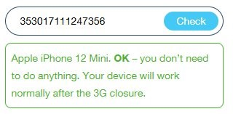 Non-eligible device 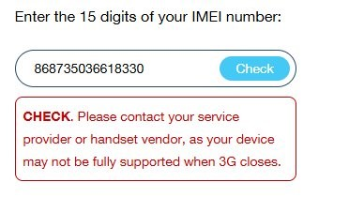  Thailand - Roaming services are not available in Pattani, Yala (e.g. Betong), Narathiwat, Chana District, Nathawi District, Thepha District and Saba Yoi District. - Due to the ongoing situation along the Thailand–Cambodia border, roaming services are temporarily unavailable in areas close to the border. This disruption is localized and limited to approximately 10 KILOMETRES from the border towards inland (Thailand) areas highlighted in red. 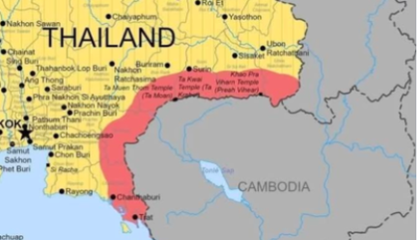  India - Roaming services are not available in Jammu, Kashmir, Assam, and Northeast regions due to restrictions set by the Government of India.  Myanmar - Internet roaming services are unavailable, but voice calls (direct dial) and SMS are available.  USA - AT&T’s 3G network was phased out on 22nd February 2022, resulting in potential intermittent voice interruptions in some areas. Please use WhatsApp calls as an alternative until further notice. - 4G networks are available for Internet browsing.  United Kingdom & Japan - EE’s and Softbank's 3G have committed to closed on 12th March 2024/15th April 2024. - 2G, 4G/LTE & 5G networks are available for Internet browsing.  China - Devices must support TD-SCDMA frequency mode while roaming on China Mobile’s 3G network.  Japan, South Korea, Singapore - 3G-enabled mobile devices are required to use roaming services.  Russia - Starting 6 October 2025, Russian mobile operators will block mobile data and SMS services for 24 hours for all roaming users upon first network registration. - The block is automatic and lifted after 24 hours. - If the SIM remains inactive for 3 days, the 24-hour block will apply again. - Voice calls are not affected and remain fully available.
FAQs | https://www.celcomdigi.com/roaming/monthly-pass
Website | https://www.celcomdigi.com/roaming/multi-day-pass

6. Internal Information

7. Reference Guide (Agent Guide, Scenario Handling and Other References)
Reference Guide

8. Historical Communications (no longer active but retained for reference only)
Inactive Comms | NA
Inactive Customer Journey | NA

